**Dinaki Language Game Player Instructions**

The Dinaki Lnaguage Game Player is the program that plays the levels created in the Dinaki Language Game Editor. The game is comprised of five areas: the HUD, the profiles, the Map, the Scenes, and the Activities.

Contents

The HUD 2

The New Button: Creating a new Profile 3

The Load Button: Editing a Profile 4

Go: Playing a Profile 4

The Arrow Buttons: Scrolling though the Profiles 5

The Delete Button: Deleting a Profile 6

The Save Button: Saving a Game 7

The Profile Button: Seeing the data of a Profile 8

The Exit Button: Exiting the Game 9

The ? Button: Opening the Help Window 10

The Back Button: Going to the previous Screen 11

The Map 12

Scenes 13

Activities 14

Matching: Match a Word to the Image 14

Pairing: Pairing a Word to an Image 15

# The HUD

The HUD is the row of gray buttons on the top of each screen, and the green Back arrow.

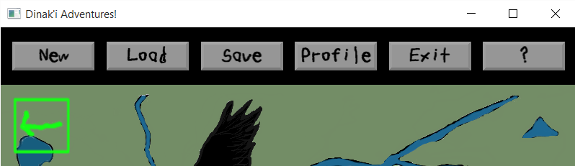

**New**: Creates new Player Profiles

**Load**: Goes to the Profile screen to load an existing Profile

**Save**: Saves the progress of the current Player

**Profile**: Shows the Name, Age, and Badges of the current Player

**Exit**: Exits the game

**?**: Brings up the Help window for that Screen

**Back Arrow**: Brings the Player to the previous Screen

## The New Button: Creating a new Profile

The New button on the HUD creates a new Profile, which are the personal accounts the players.

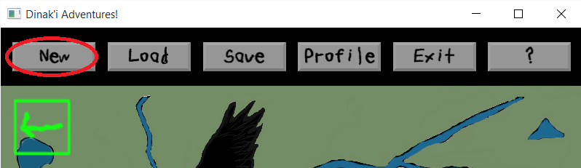

To create a new Profile, select the New button on the HUD, and enter a name. The player can use the keyboard on the screen, or the physical keyboard. Then, click the **Done** button:

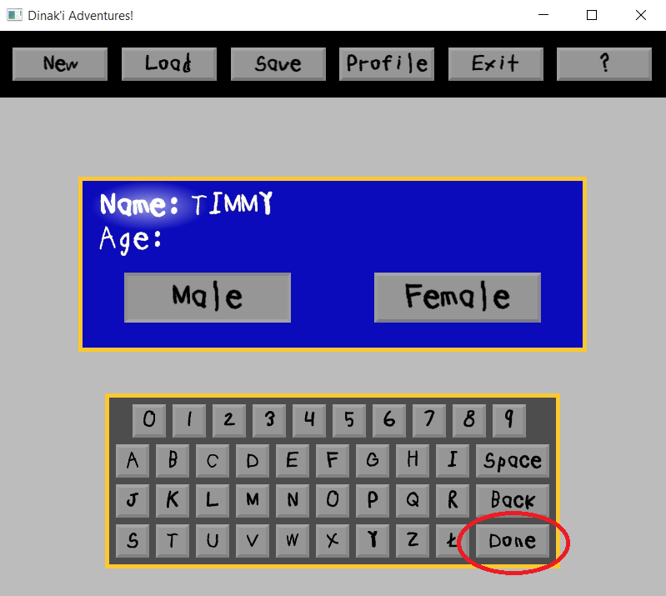

The Age should now be highlighted. Enter the Age, and select the gender. Click the **Done** button to finish creating the Profile:

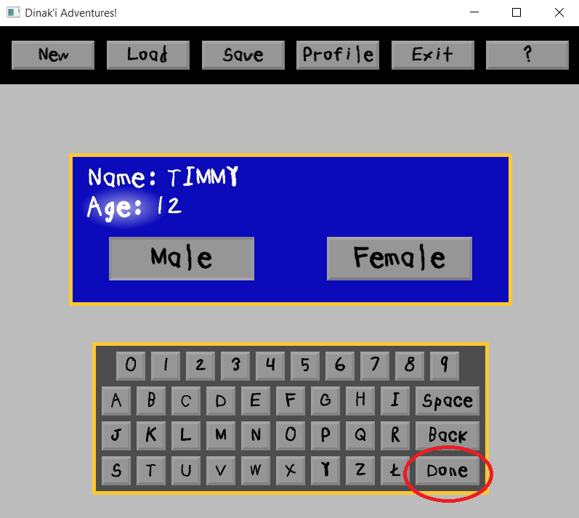

To cancel creating a Profile, click the New button again.

## The Load Button: Editing a Profile

The Load button brings the Player to the Profile selection Screen. Here, the Player can select a Profile to play, scroll through Profiles, and delete Profiles.

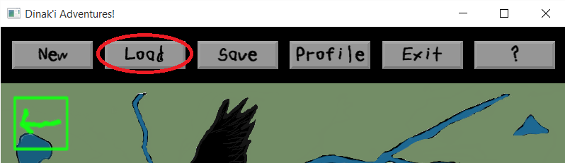

### Go: Playing a Profile

Selecting a Profile, and then clicking the **Go** button takes the Player into the game with that Profile:

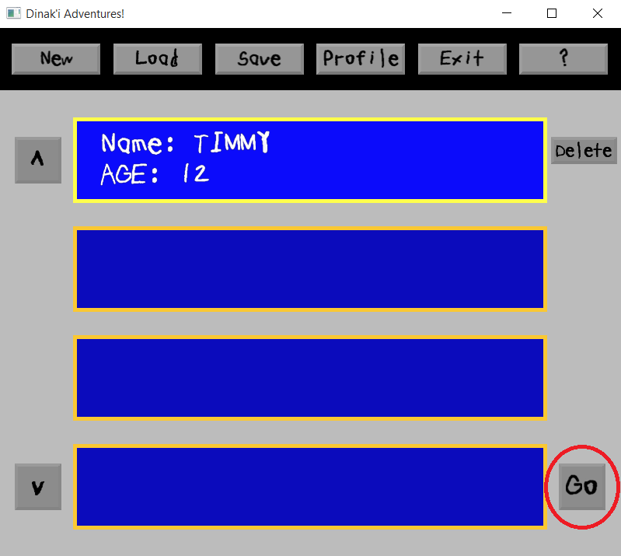

### The Arrow Buttons: Scrolling though the Profiles

When there are more than four existing Profiles, not all of them will be visible. By using the up and down arrow keys on the physical keyboard or the Screen, the player can access the other Profiles:

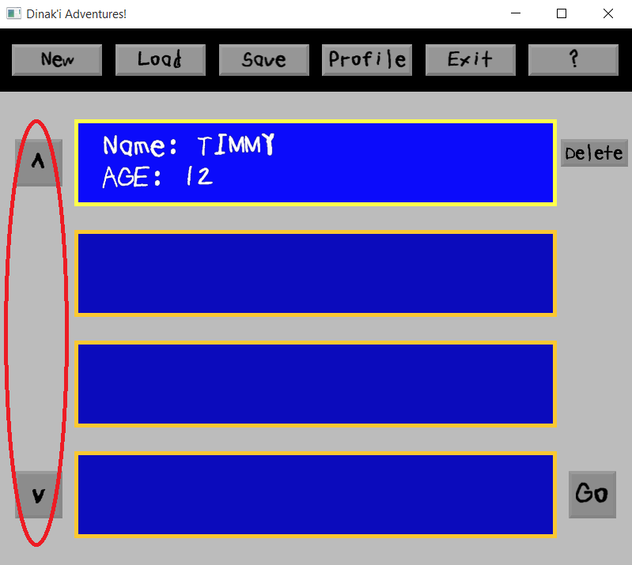

### The Delete Button: Deleting a Profile

If the Player wants to delete their Profile, they can select the Profile, and then click on the **Delete** button:

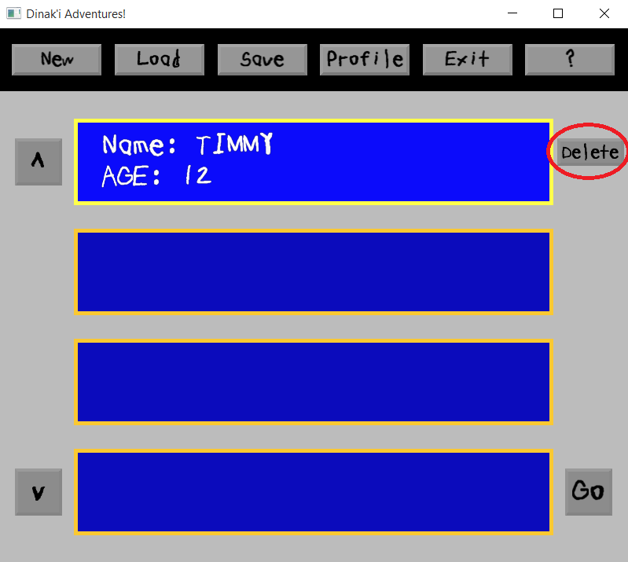

## The Save Button: Saving a Game

The Save button saves the current progress of the Player. It should be noted that the game automatically saves after finishing Activities as well:

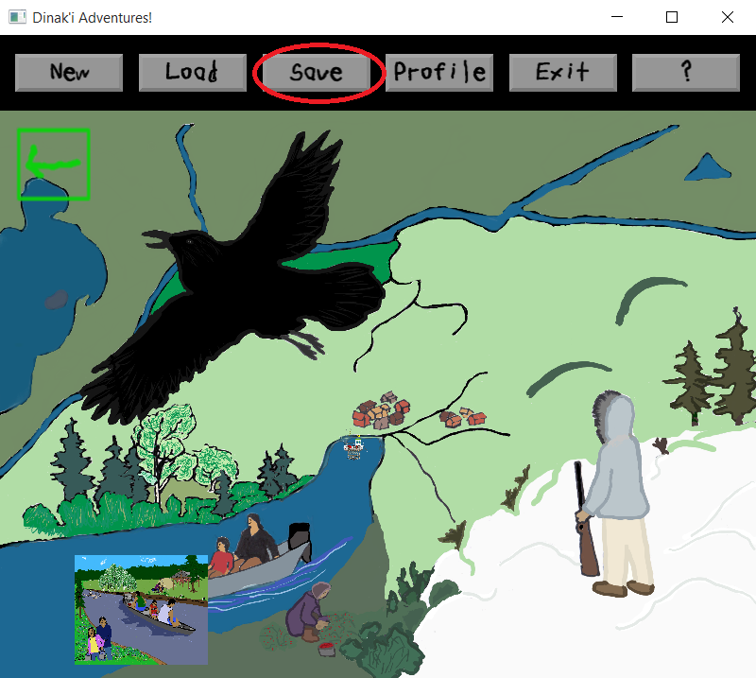

## The Profile Button: Seeing the data of a Profile

The Profile button shows the data of that Player’s Profile. The data shown is the Name, Age, and the Badges and Badge Pieces that Player has earned. The row of Badges/Badge Pieces can be scrolled through by using the left and right arrow keys on the physical keyboard.

To view the Profile on the Profile loading Screen, select a Profile, and then clicking the **Profile** button. If a game session is in progress, just press the **Profile** button. To close the Profile window, click the **Profile** button again:

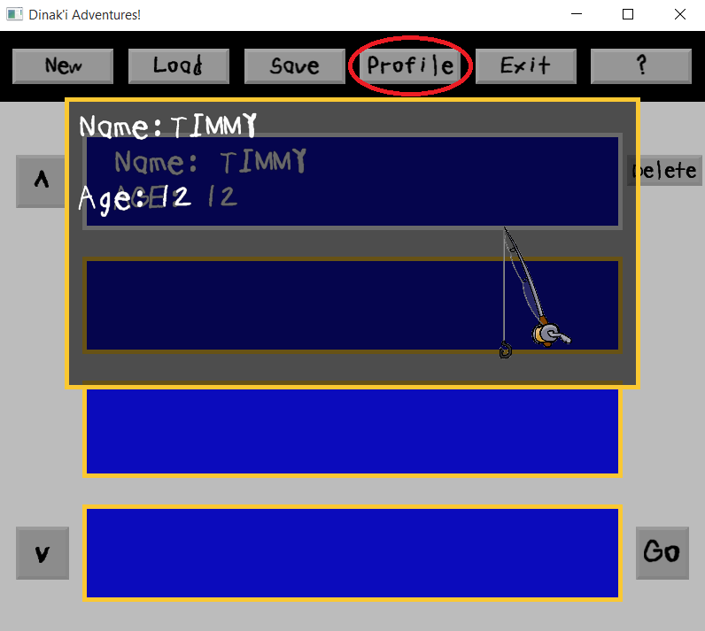

## The Exit Button: Exiting the Game

The Exit button ends the game and closes the program. This can also be done by pressing the close button (the **X** at the very right-hand top of the game’s window):

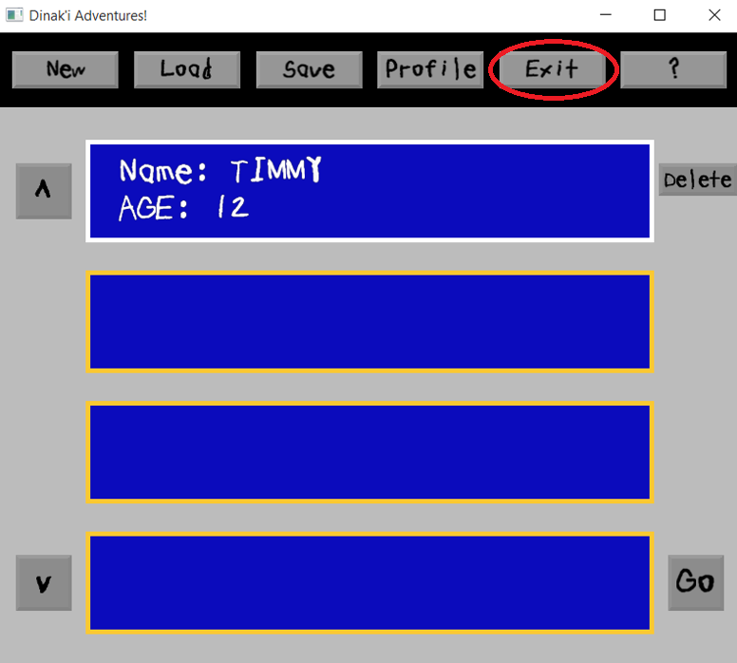

## The ? Button: Opening the Help Window

The ? button opens that Screen’s Help window. This window provides instructions for the Player for how to use that Screen, for example, on an Activity, it tells how to play the Activity, on the Map it tells how to get to Scenes and then Activities, and on the Profile creation Screen, it tells the steps of creating a Profile.

To open the Help window, click the ? button, and then click it again to close the Help window:

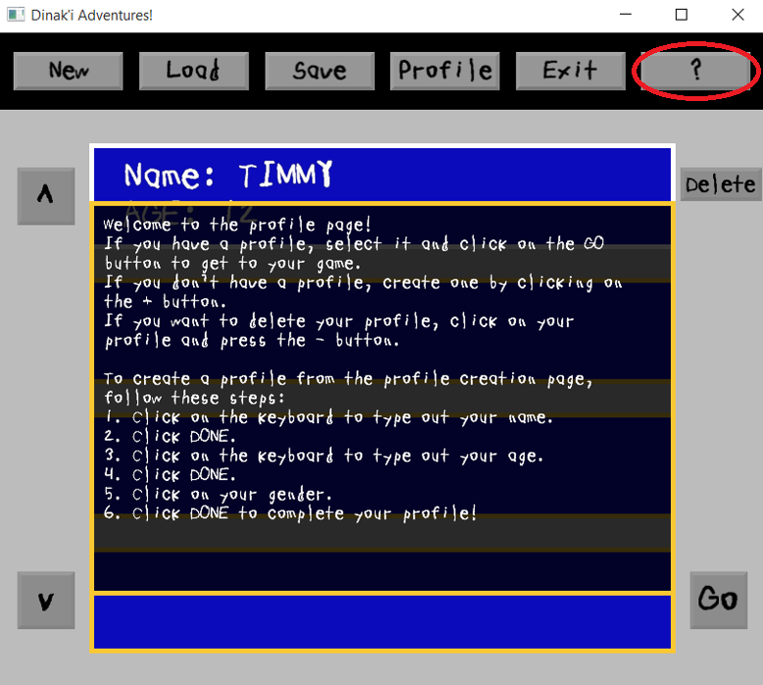

## The Back Button: Going to the previous Screen

The green arrow button in the top left of the Screen is a Back button that will return the Player to the previous Screen. These are on the Map, Scene, and Activity Screens. Clicking it on the Map brings the Player to the Profile Screen, clicking it on a Scene brings the Player to the Map, and clicking it inside of an Activity brings the Player back to the Scene that contains that Activity:

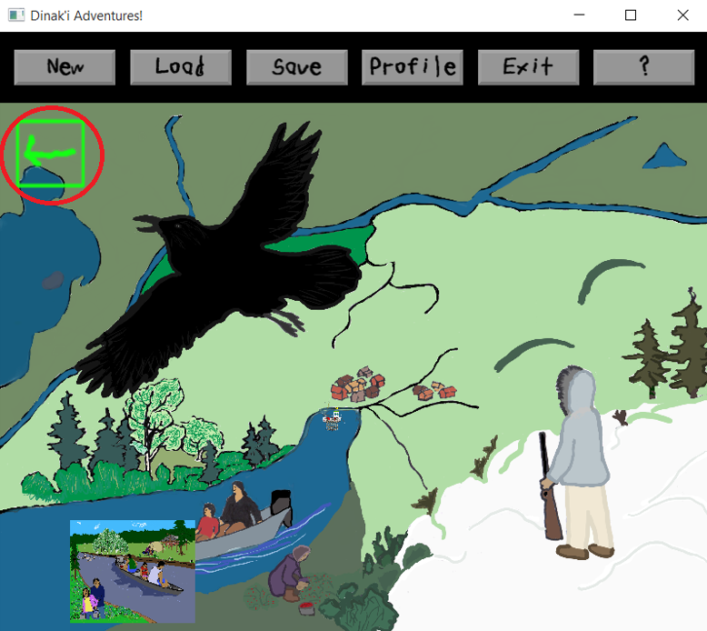

# The Map

The Map is where the Player begins each game session. This Screen provides an overview of the area they can access, and are where they can select a Scene to go to. If a Scene requires no Badges, they will always be able to access it. If the Scene requires a Badge, they will only be able to access it if they have that Badge:

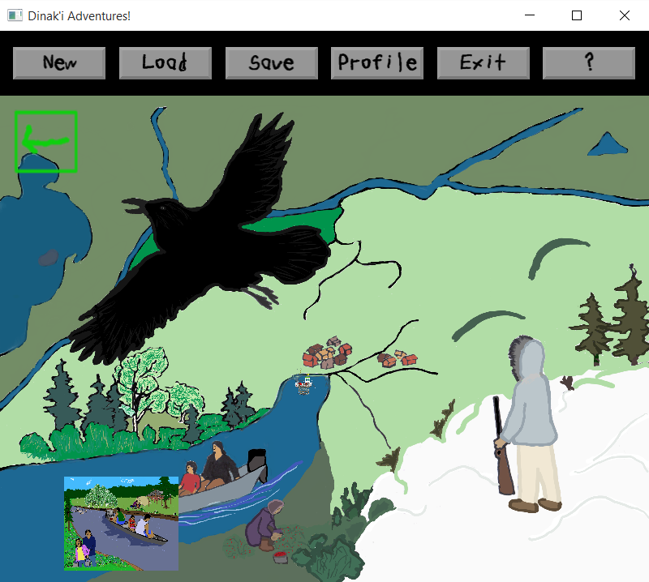

# Scenes

The Scenes are certain areas of the Map, such as a campsite or a town. Here, the Player can select items on the Screen to go to Activities. If multiple items in the Scene have the same Activity set to them, the Player will need to select each item to go to the Activity:

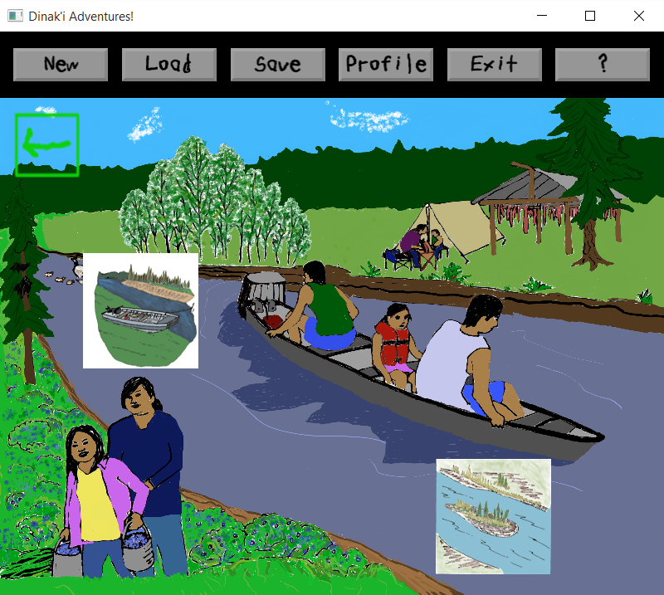

# Activities

The Activities are where the Player learns to associate the words of the Dinaki language to images. There are two types of Activities, Matching and Pairing. Each Activity will give the Player a Badge if they got a high enough Score.

## Matching: Match a Word to the Image

In the Matching Activity, the Player is challenged to select the Word on the Left side of the Screen to the Image on the right. The Player can click on the Image to hear the correct Word pronounced:

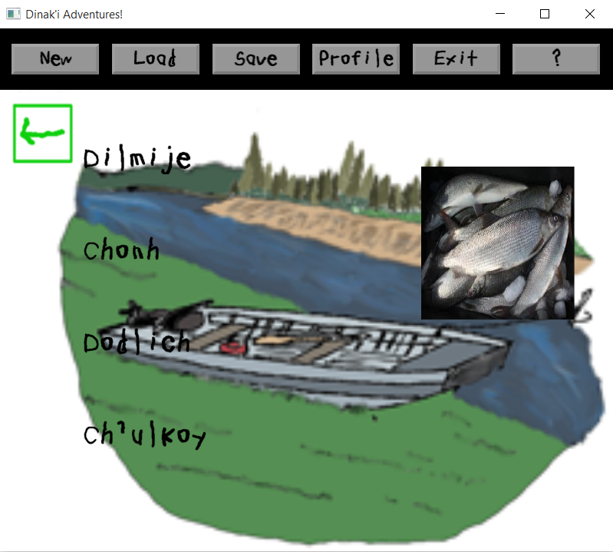

## Pairing: Pairing a Word to an Image

In the Pairing Activity, the Player is challenged to select a Word on the bottom side of the Screen, and then select the corresponding Image on the top of the Screen. The Player can click on a Word or Image to hear the Word pronounced, and unselect the Word or Image by clicking on it again:

